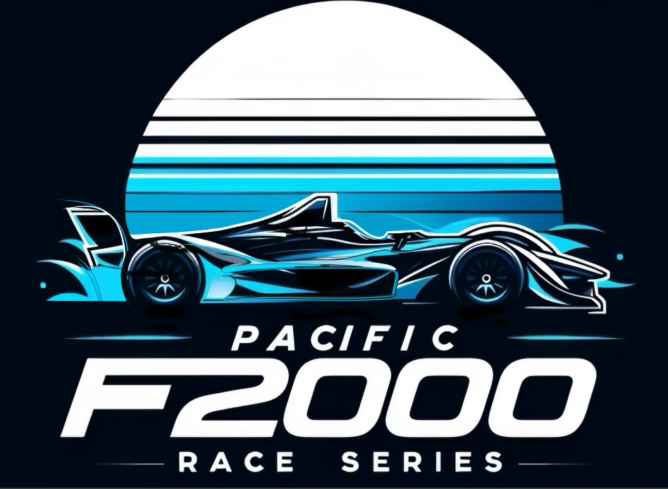
Russell and Petty trade wins at Buttonwillow in instant classic
A solid 16 car field turned up at Buttonwillow for the October rounds of the Pacific series and were greeted with 70 degree temperatures and lots of sunshine. The two Canadian drivers who made the trek down, Jeremy Hammond and Chris Britten must have thought they were back in July since it’s probably frozen over at their home base by now. We also had Jon Nicastro making his racing debut in a car he had barely sat in before the weekend. His two finishes of 7th and 8th while keeping his nose clean were a pleasant revelation.
During the Saturday race, it was a knock down drag out battle between the 24 of points leader Jase Petty, the 87 of pole winner Troy Shooter, the 84 of Dutch Schultz and the come from behind challenge of Trevor Russell who had a transponder issue in the morning qualifying session, forcing him to start at the rear. Early on it was Petty with the upper hand as Russell carved through the field. By half distance he had made it to the bumper of the DFR 24 car and was pushing for the lead. The two lead cars went side by side through Riverside on lap 8 and somehow made it out in one piece. A hiccup by Trevor in the Grapevine section allowed Petty to get away and seal the victory, with Shooter finishing a fine second and Schultz rounding out the podium.
Throughout the field battles raged, one nice surprise was Nick Kodenko of Santa Clara who was nursing a sick motor all weekend but was somehow able to hold off numerous charges to keep his car in the top half of the field for most of the event. The VD of newcomer Hammond was also on pace and did a fine job during his first trip to Buttonwillow, even scoring a 5th on Satruday while also winning one of the free tire sets. We even had a pair of Pinto class cars doing battle, the 1996 Van Diemen of Shawn Sarbacker and the VD of Canadian Chris Britten with Paul MacFarlane mixed in between for good measure. Also with a fine run all weekend was Mark Peller, the rocket engineer making his 2025 debut (better late than never) came home with a drama free 4th and would finish one spot lower on Sunday in 5th.
Arizona driver Jim Bryant came away with a solid 7th, Jon Nicasto in 8th, John Fabijanic 9th, Mark Russell in a last minute loaner DFR VD in 10th, Cipriano ended in 14th and the lone DNF came from Nick Coe in 16th who found a barrier that would end his weekend.
Sunday was all Russell. He pulled the hat trick with pole by 2 tenths over Petty, fast lap and the win. He slowly pulled away each lap and would come home 5 seconds in front of points leader Petty, the Illinois driver playing it smart and increasing his lead over second place in points Troy Shooter, who would wind up 4th. Shooter did win one of the tire giveaways thanks to sponsor Silicon Salvage. Schultz, driving better each week and continuing to find pace, finished out his weekend with a fine and well deserved third place.
In race 2 once again the two pinto cars ran solid, with Britten even garnishing a top 10. Bryant would have a massive off in Riverside but somehow would continue and end up in 13th.
Nicastro, CEO of event title sponsor Battle Lab, would come home 7th on Sunday, finishing ahead of some serious talent in his first car race. Mark Russell would again crack the top 10 in his loaner Peter West VD to get 9th. Cipriano, in his beautiful red Van Diemen rounded out the field, a field with zero DNF’s.
Along with the racing, we had a great time with the get together dinner Saturday evening, with all the teams and drivers in attendance. We need to again thank Battle Lab, of course Silicon Salvage, Primus Racing, Buttonwillow Raceway, Fast Forward, Speed Seat, Gear Daddies, Detail Gurus, Kodenko Automotive, DFR, Quicksilver Engines, and all those who make this possible.
It’s a short three weeks until the Pacific F2000 circus rolls back into Buttonwillow for the final two rounds to play out on the new Circuit, and we crown a 2025 Champion! See you all there!!

